Enclosure

Once complete please use the questionnaire link (https://www.msiac.nato.int/energetic-materials-qualification-questionnaire) to submit the form or email directly to m.andrews@msiac.nato.int or c.collet@msiac.nato.int. Please add your national country code (e.g. FRA, DEU, GBR, USA) in the file name so we can track submissions.

Qualification process for Energetic Materials | Who is in charge? Individual? Authority? Board? | Reference documents? International or national standard? Internal procedure?
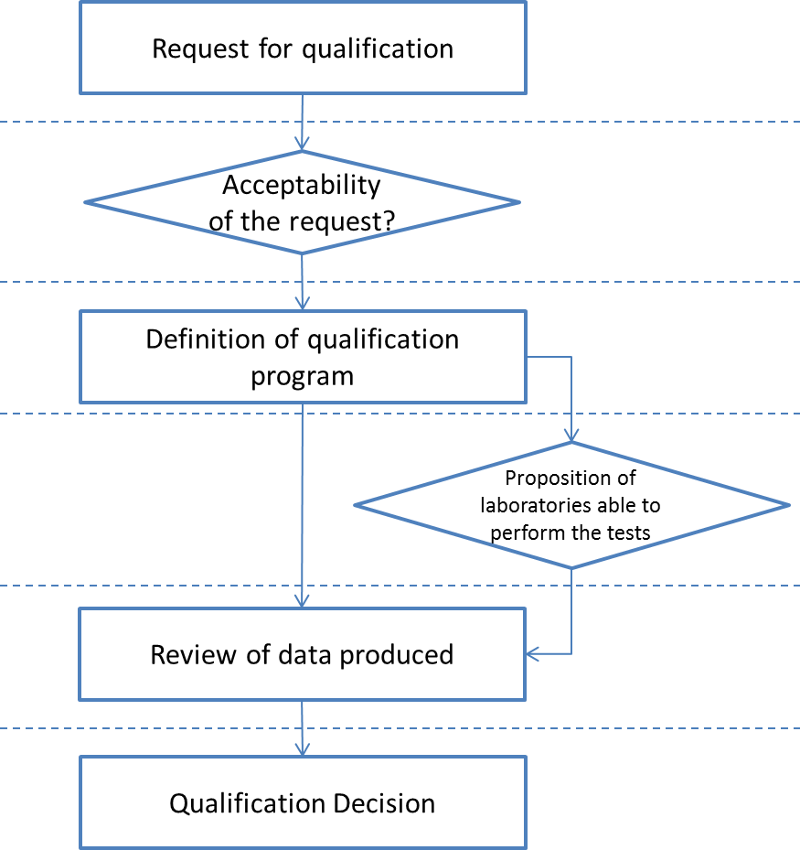
After the qualification process
Ownership of qualification data
Access request to qualification data: national request or from another nation.

